Mahoney 1
Story 1
Meritt Mahoney
Page/MC 2040
29 January 2023

Pharmacies all around the United States are dealing with a shortage of attention deficit/hyperactivity disorder or ADHD drugs. This shortage is becoming a problem for high school and college students because some of them are unable to get the medicine they need in order to succeed in school.
The shortage of the three main ADHD drugs Adderall, Vyvanse, and Concerta, is due to a lack of workers at the major factories that produce the prescription drugs according to licensed psychiatrist Hillary Butella. She also said that there are not enough supplies at the moment to actually create the drugs either.
“Even if there were enough workers who could get the job done, there is not enough supplies and equipment to go around,” Butella said.
Butella has been having to ask her clients to call different pharmacies themselves to see if the prescription they are in need of could even available to them at the moment.
“I have too many clients that are in need of ADHD medication, so I have had to tell them to take it upon themselves to call the pharmacies in their city to see if they have the medication in stock,” Butella said.

Mahoney 2
A graduate student in school for accounting at Louisiana State University, Jake Fisher, said he struggles with ADHD. After Christmas break, he needed a refill of his Adderall because he said that he cannot focus without it.
“I called about twelve different pharmacies and none of them had my medicine available,” Fisher said.
It has been two weeks since classes have started back up and he still has not been able to get his hands on the prescription medicine that he needs.
“The shortage of my medicine has really affected me in a negative way,” Fisher said.
Fisher said that he has been having the hardest time focusing in his accounting classes and he already feels behind in the spring semester.
“Some of the material that I should have studied and mastered by now I have not been able to because I truly need Adderall to help me,” Fisher said.
He said that he gets very scatter brained and cannot focus on more than one thing at once without his medicine. He also said that it is not crucial for his day-to-day life to have the medicine, but during school hours and when he needs to study, he feels it is mandatory that he has it.
“If this shortage does not get fixed soon, I am worried that I will not make my grades for the first time since I started my medicine four years ago,” Fisher said.
Butella said that students should inform their professors of this shortage in order for them to be aware of the students who may be in need of extra help in class.
A sociology professor at LSU named Ginger Stevenson said she is sympathetic for the students that are affected by this shortage.
Mahoney 3
“I understand that students are under a lot of pressure, and I also understand that some students are in need of assistance from prescription medication,” Stevenson said. “I try to be as fair and understanding as possible.”
Stevenson said that there have been a few students that have opened up to her about their recent struggles in school due to the shortage of the ADHD medicine. She said that because of LSU protocols and the lesson plans they have set for each course, it is sometimes hard to figure out ways to be lenient on students, but she wants to do everything she can to make things easier.
Another LSU student from Houston named Kara Kirby has also been affected by the ADHD drug shortage. Kirby is a freshman majoring in business and has been taking Vyvanse since she was a sophomore in high school.
“There have been shortages before, but I have always been able to find at least one pharmacy in Houston that has Vyvanse left,” Kirby said.
Kirby has had no luck finding her medicine in Baton Rouge since school has started.
“I had a hard time in high school without medicine to keep my ADHD in check but luckily I barely had to experience that,” Kirby said. “But now I am newly in college, and I do not have the one thing I need that helps me do better in school.”
Butella said that she thinks it will continue to be difficult to find any ADHD medicine near Baton Rouge any time soon since so many college students need it.
“Even if the medicine is renewed soon, it will sell out again within no time,” Butella said. “Medicine shortages are like a ripple effect.”
She said that each day another student runs out of their medicine so each day that adds another student that cannot get new medicine.
Mahoney 4
“This cycle quickly adds up,” Butella said.
She worries that if this shortage lasts much longer student schools will start to see a decrease in students GPA.
“I can only hope that things get sorted out as soon as possible because I do not like to see students suffer,” Butella said.
As a psychiatrist, Butella said that she often sees the effect that the lack of this medicine can cause students.
“Students are under so much pressure, and I really do not want this shortage to be another reason for students to stress out,” Butella said.

Sources:
Hillary Butella: Phone- 713-677-3137 Email- hillarybutella@lifespringbehavioral.com
Jake Fisher: Phone- 225- 368-7392 Email- jfisky@gmail.com
Kara Kirby: Phone- 832-726-5558
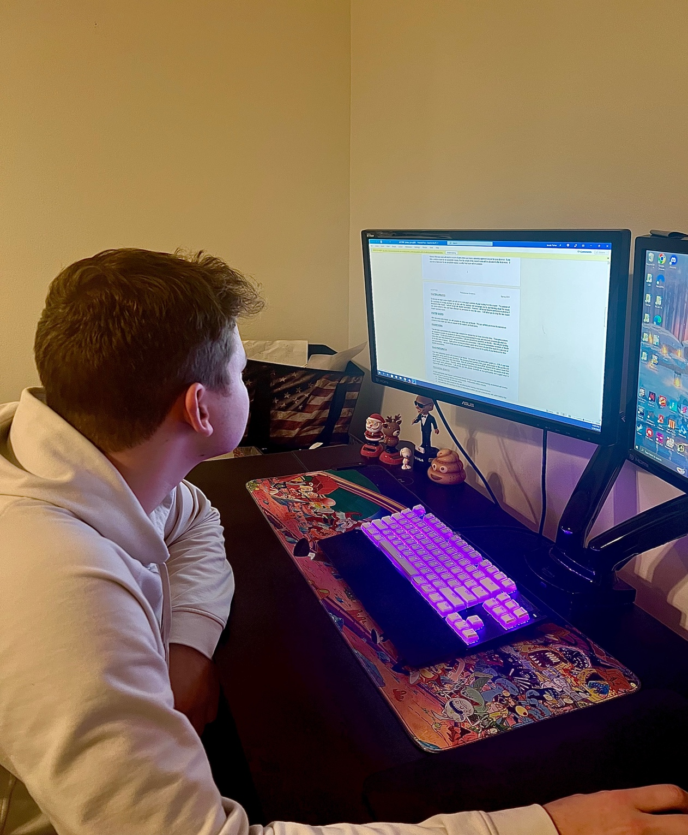
Jake Fisher trying to focus on his schoolwork without the help of his Adderall.

