STORY 4

Meritt Mahoney

Professor Page MC 4060

12 April 2022

**Women in sports are more at risk than men of severe concussions that have physical and mental effects that could last them a lifetime.**

The media has been reporting on concussions in men’s sports such as football, soccer, rugby, and many more for decades. Something that the media does not report on as much are concussions in women’s sports, and how it affects the female’s physical and mental state after the injury more heavily than it does a male.

Data shows that concussion rates among females have increased 118% from 2010 to 2015 and those rates have continued to go up throughout the continuing years according to The Blue Cross Blue Shield Health of America. The male concussion rate only went up 48%. Their data set also shows that 61.3% of females ages 20-64 suffer from post-concussion syndrome, meaning dizziness, memory loss, sleep issues, and mood problems, whereas only 38.7% of males suffer from the same syndrome. One of the reasons for these differences is partially because female’s have a weaker neck strength which makes it easier for the head to move when impacted.

Marlie Clayton, who is now freshman at the University of Alabama, played soccer in high school. She was on the road to playing in college until she sustained a life altering concussion during one her school’s playoff games.

“It is crazy to think about how much my life has changed after just being kicked in the head,” Clayton said. “My dreams kind of went from almost being a reality to being a memory.”

Clayton’s concussion was severe, and she endured a small brain bleed that came with all of the symptoms of post-concussion syndrome including memory loss. Clayton said she is back to normal for the most part, but her soccer days are far behind her. She said that the only thing that worries her is her future.

After Clayton was finally healed from her head trauma, her doctor informed her that there could quite possibly be some lasting long-term effects.

“I am in danger of having dementia when I am older because of my brain injury and my concussion has also had lasting effects on my mood and mental state,” Clayton said.

Her doctor, Doctor Ginger Patel, explained to her that women are more likely than men to suffer long-term effects even if their concussion is just as bad.

“Men and women recover at a similar speed for outside bodily injuries like breaking a leg, but when it comes to brain damage or concussions, women recover much slower and have more long-term effects,” Dr. Patel said.

Dr. Patel said one of the reasons for the slow recovery and long-term effects of the female brain after an injury is because women have a lower threshold for tolerance when the head is impacted. Another reason that concussions affect females more is because of hormones. Hormones can affect the female brain’s recovery because the brain has more receptors for estrogen, which only males have Dr. Patel said.

“A lot of female patients that get concussions are in danger of memory loss, sporadic nausea or vomiting, fatigue, slurred speech, and mood changes,” Dr. Patel said. “Most times, depending on how severe the concussion is, women are more in danger than men are in gaining dementia when they reach a certain age because of their brain injury.”

After Clayton did loads of physical therapy and met with Dr. Patel many times, she came to the conclusion that she will live her life more carefully and try to stimulate her brain as much as possible by doing exercises every day, reading, and just living a healthy life so that there is less of a possibility of the long-term effects kicking in when she ages.

“Dr. Patel told me that I am lucky that my injury did not affect my present life more than it did and to try to live my life in the healthiest way possible so there is less of a risk that I will have dementia,” Clayton said.

Dylan Mayberry, a former Louisiana State University volleyball player has had to step away from the game for a while due to a concussion. Mayberry was in the middle of a volleyball game in 2021, and LSU was losing to Rice.

“I was really trying to save the game for my team and ever since I was a little kid playing volleyball, I always felt like the team and my coaches were relying on me to carry the game on my back,” Mayberry said.

There was a volleyball flying over the net towards her, Mayberry said, and she knew that she had to do everything she could to successfully return it to the other side. As the ball was approaching Mayberry, she said it was coming in so hot and fast that she had to dive to the ground to reach it. That was when the incident happened. Mayberry’s head hit the ground hard.

“Everything went black for a minute, but I do not think anyone really realized what happened,” Mayberry said.

When Mayberry went to the hospital she was diagnosed with a mild concussion. Her doctor told her that if the injury was even a little worse, she could have obtained the possibility of brain bleeding or memory loss, but luckily she only experienced mild symptoms like dizziness.

“I know of men who are my age that have been concussed and also of women,” Mayberry said. “The men always recover quicker.”

Mayberry took a break for a while from volleyball but has since regained her confidence and now plays again.

Women and men have different strengths and weaknesses in all aspects of life because they are built chemically different. Women are more at risk of severe concussions that have effects that could possibly last them a lifetime.

SOURCES:

Dr. Ginger Patel- [gingerpatel@highlandwoodshealth.com](mailto:gingerpatel@highlandwoodshealth.com) /281-292-1192

Dylan Mayberry- [dylanmayberry@gmail.com](mailto:dylanmayberry@gmail.com) / 504-295-7632

Marlie Clayton- [marlieclay03@gmail.com](mailto:marlieclay03@gmail.com) / 713-387-9848

Data: <https://www.bcbs.com/the-health-of-america/reports/the-steep-rise-concussion-diagnoses-the-us>

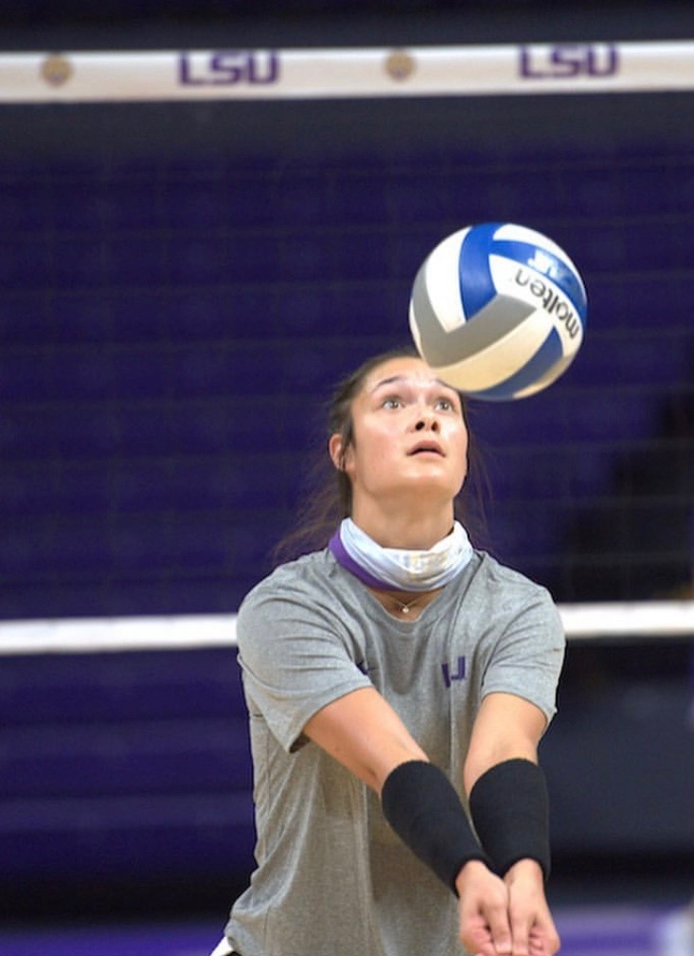

Mayberry in practice gear post-concussion.

Mayberry jumping for a high ball post-concussion.